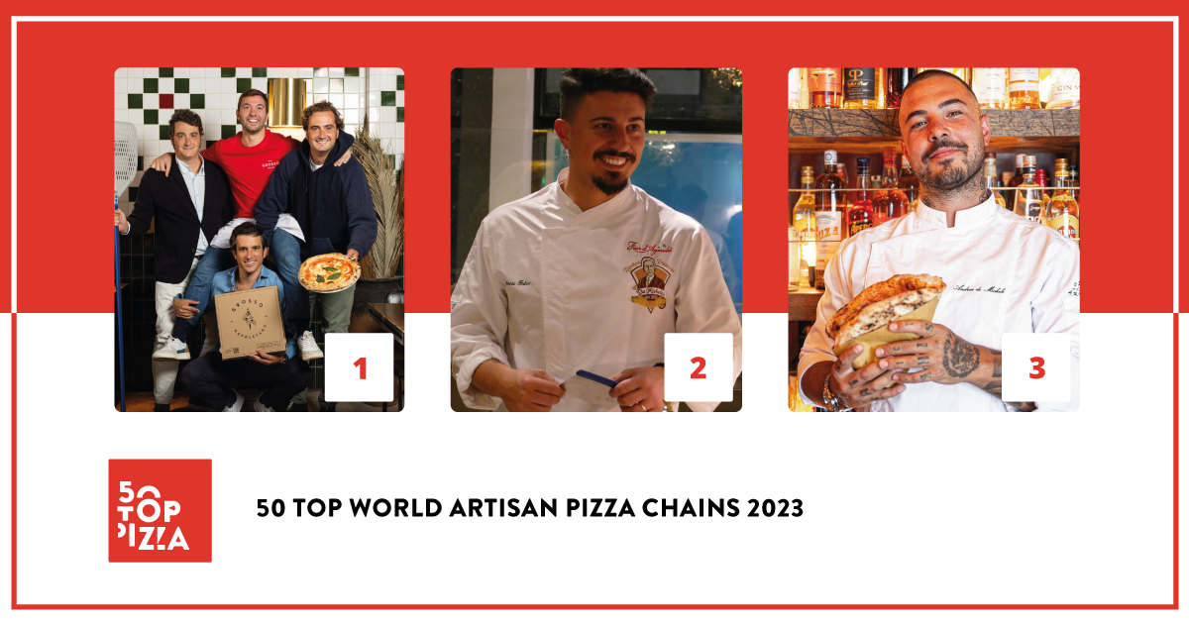

50 TOP WORLD ARTISAN PIZZA CHAINS 2023:
GROSSO NAPOLETANO HAS BEEN CROWNED AS THE BEST ARTISAN PIZZERIA CHAIN IN THE WORLD. IN SECOND PLACE IS DA MICHELE; IN THIRD, BIG MAMMA GROUP.

November 23rd 2023 – 50 Top World Artisan Pizza Chains 2023 was presented yesterday evening at the historic San Ferdinando theater in Naples. It is a ranking of the best artisan pizzeria chains in the world curated by 50 Top Pizza, the most important guide in its sector under the direction of Barbara Guerra, Luciano Pignataro and Albert Sapere.

For the first time ever, Grosso Napoletano managed to place first in this year’s ranking as the best artisan pizzeria chain in the world. Opened in 2017, it has since then introduced the Neapolitan-style pizza to Spain; first to Madrid and then to Barcellona, Seville, Saragozza and in other centers along the Iberian peninsula. In second place this year is Da Michele, a chain which had captured the top spot for the previous two years. Opened 150 years ago in Forcella in Naples, today it has locations in Japan, England, Spain, the United States, the United Arab Emirates and Germany in addition to locations in Italy. In all of their venues it is possible to enjoy their celebrated “wagon wheel” (a ruota di carro) pizza. In third place is Big Mamma Group, a business that was opened because of two French businessmen’s love for Italy: Victor Lugger and Tigran Seydoux. Today the chain boasts numerous locations in France, Spain, England and Germany.

Fourth position was captured by Bráz Pizzaria, a Brazilian enterprise famous for its large and crunchy pizzas baked in a wood-fired oven. In fifth place is Berberè, owned by the Aloe brothers. They began with a single pizzeria in Castel Maggiore in the province of Bologna, subsequently opening numerous locations in Rome, Florence, Turin, Milan and finally London. Position number six belongs to 400 Gradi which has outlets in both Australia and the United States of America. The owner and founder Johnny Di Francesco has the honor of being the current ambassador for Neapolitan-style pizza in the new continent. Seventh position went to Pizzium, which has recently opened its 50th location in Italy, all of which are managed directly. Eighth position has been captured by Errico Porzio’s pizzerias. They can be found in the Campania and Lazio regions and propose pizzas in the classic Neapolitan style as well as pan pizzas, a format that has been just as successful as the other. In ninth position is Luigia, which has locations in Switzerland and Dubai and proposes pizzas with a selection of premium-quality toppings from Italy. Closing the top ten is a new entry: Peppe Pizzeria by Giuseppe Cutraro, with locations all over Paris.

There are six pizzeria chains which have for the first time earned a Green Oven award. This prize recognizes pizzerias who pay particular attention to environmentally sustainable practices. This year’s recipients are: Berberè, Garden Pizza, Luigia, Menchetti, Pizzium and Sodo Pizza.

The much-anticipated special awards were assigned as follows: the Pizza of the Year 2023 - Latteria Sorrentina Award went to the legendary Hellboy® at Paulie Gee's; the New Entry of the Year 2023 - Solania Award was captured by Peppe Pizzeria; the Performance of the Year 2023 - Robo Award went to Pizzana; the Best Wine List 2023 - Asti DOCG Award went to Doppio Zero; the Best Service 2023 - Goeldlin Award was given to Luigia; the Best Marketing 2023 - Mammafiore Award was captured by Errico Porzio; the special Innovation and Sustainability 2023 - Ferrarelle Award went to Pizzium; the Best Pasta Proposal 2023 - Pastificio Di Martino Award was given to 400 Gradi; the One to Watch 2023 - Fedegroup Award was captured by Garden Pizza; the Best Beer and Drink Service 2023 - Birrificio Fratelli Perrella Award went to Cocciuto; and finally, the Best Fried Food - Il Fritturista 2023 - Oleificio Zucchi Award, was captured by Peppina.

A new feature in this edition is the insertion of the “Excellent” category, or in other words, those artisan pizzeria chains which are highly recommended in addition to the chains that made the ranking. The complete guide, therefore, has a total of 75 brands.

“We are extremely proud of the work carried out for 50 Top World Artisan Pizza Chains 2023 - declare the three curators of the guide Barbara Guerra, Luciano Pignataro and Albert Sapere - The artisan chains present in this year’s guide, that is, those who have reached the quality standards demanded by our inspectors, are 75 in number with over 1200 locations and over 20.000 direct employees with a total revenue that surpasses 2 billion dollars. It is a format that is in continual growth, that knows no crisis and which is a testament to the fact that pizza is the most popular prepared food in the world.”

Project Partners:
Birrificio Fratelli Perrella, Consorzio dell’Asti DOCG, Fedegroup, Ferrarelle, Goeldlin, Latteria Sorrentina, Mammafiore, Oleificio Zucchi, Pastificio Di Martino, Robo 1938, Solania.

The following is the Complete Ranking for 50 Top World Artisan Pizza Chains 2023
1. Grosso Napoletano
2. Da Michele
3. Big Mamma Group
4. Bráz Pizzaria
5. Berberè
6. 400 Gradi
7. Pizzium
8. Errico Porzio
9. Luigia
10. Peppe Pizzeria
11. Pizza Pilgrims
12. IQuintili
13. Sorbillo
14. Vincenzo Capuano
15. Paulie Gee's
16. Pizzana
17. Motorino Pizzeria Napoletana
18. Doppio Zero
19. Peppina
20. Menchetti
21. Riva
22. Starita
23. NAP Neapolitan Authentic Pizza
24. Can Pizza
25. Pitfire Pizza Dubai
26. 1900 Pizzeria
27. Fresco
28. Alice Pizza
29. Fratelli La Bufala
30. Rossopomodoro
31. Fradiavolo
32. Don Peppe
33. Via Tribunali
34. Madison
35. DaZero
36. Gruppomimo
37. OLIO welovepizzanapoletana
38. Zia Lucia
39. Cocciuto
40. Cinquecento
41. Lievità
42. Vasinikò
43. Napulé
44. Mammamia!
45. Santa Maria
46. Garden Pizza
47. Farinella
48. Villa Paradiso
49. Crocca
50. Pummarola
50. Pizzatopia

Special Awards - 50 Top World Artisan Pizza Chains 2023
• Best Pasta Proposal 2023 - Pastificio Di Martino Award
400 Gradi

• Innovation and Sustainability 2023 - Ferrarelle Award
Pizzium

• Best Marketing 2023 - Mammafiore Award
Errico Porzio

• Best Service 2023 - Goeldlin Award
Luigia

• New Entry of the Year 2023 - Solania Award
Peppe Pizzeria

• Pizza of the Year 2023 - Latteria Sorrentina Award
Hellboy® by Paulie Gee's

• Performance of the Year 2023 - Robo Award
Pizzana

• Best Wine List 2023 - Asti DOCG Award
Doppio Zero

• Best Fried Food - Il Fritturista 2023 - Oleificio Zucchi Award
Peppina

• Best Beer and Drink Service 2023 - Birrificio Fratelli Perrella Award
Cocciuto

• One to Watch 2023 - Fedegroup Award
Garden Pizza

50 Top World Artisan Pizza Chains 2023 – Green Oven
• Berberè
• Garden Pizza
• Luigia
• Menchetti
• Pizzium
• Sodo Pizza

50 Top World Artisan Pizza Chains 2023 – Excellent Pizzerias
• Dough Bros.
• Eataly
• Frank Pepe Pizzeria
• Il Giardino degli Dei
• Mamma Dough
• Mamma Jamma
• Mani Pizza & Cucina
• Meno Male
• Nine o Five
• Piatto
• Pizza Union
• Pizza Verde
• Pizzeria Libretto
• Plank Sourdough Pizza
• Princi
• Pupatella
• Roberta’s
• Rudy's
• Savoy
• Settebello
• Sicilia in Bocca
• Sodo Pizza
• Tutta Bella
• Yard Sale Pizza

As with all of the rankings under the 50 Top brand, also 50 Top World Artisan Pizza Chains 2023 came to fruition thanks to the annual labor of our inspectors that collaborate with this project and that have examined an enormous number of pizzerias throughout the entire world. As per guide policy, all inspections are carried out anonymously. Factors taken into consideration for assessment include the care given, on the whole, to the well-being of the customer, which clearly begins with the quality of the products used. In the specific case of our artisan chains, brands must have a minimum of five locations to be eligible. Pizzerias with different names which are affiliated with the same master pizza maker are also eligible for consideration.

