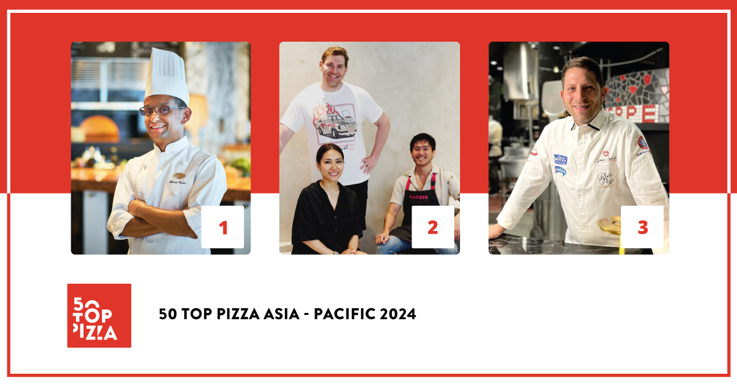
50 TOP PIZZA ASIA - PACIFIC 2024:
THE PIZZA BAR ON 38TH IN TOKYO HAS BEEN CONFIRMED AS THE BEST PIZZERIA IN THE ASIA-PACIFIC AREA
In second position is Crosta Pizzeria from Makati, in the Philippines. Third position has gone to RistoPizza in Tokyo.
The Pizza Maker of the Year is Yuichi Ito from Crosta Pizzeria, in the Philippines. The Pizza of the Year is the Provola e Pepe at Fiata by Salvatore Fiata in Hong Kong.
Fresca, in the Jordan Valley, has captured the One to Watch award.

Tokyo, March 4th2024 - The Pizza Bar on 38th has been confirmed as the best pizzeria for 50 Top Pizza Asia - Pacific 2024. It is actually the smallest pizzeria in the world, with seating only for 8. It is directed by Daniele Cason, the executive chef at the Mandarin Oriental in Tokyo. During the awards ceremony presented by Imma Romano at the Istituto Italiano di Cultura in Tokyo, Japan, 50 Top Pizza, the most influential guide in the pizza sector, revealed the ranking for the 50 best pizzerias in the Asia-Pacific area for 2024.
In second position is Crosta Pizzeria in Makati, in the Philippines, directed by Yuichi Ito, who has also captured the special award Pizza Maker of the Year 2024 – Ferrarelle Award. Completing the podium is RistoPizza in Tokyo, a newly-opened venue by Giuseppe Errichiello.
In fourth place is Fiata by Salvatore Fiata in Hong Kong, who also took home the Pizza of the Year 2024 – Latteria Sorrentina Award, with his Provola e Pepe; occupying the fifth place is a dead heat between Al Taglio by Silvio Groppelli in Sydney, and 48h Pizza e Gnocchi Bar by Michele Circhirillo and Fabio Biscaldi in Melbourne. The latter also took home the Best Beer Service 2024 – Peroni Nastro Azzurro Award; for the sixth position we travel over to Auckland, New Zealand, with Dante's Pizzeria Napoletana under the direction of Enis Baçova; seventh position has gone to Massilia in Bangkok, Thailand, led by Luca Appino and Michele Fernando, who have also taken home the Best Fried Food 2024 - Il Fritturista - Oleificio Zucchi Award; we go back to Japan for eighth position which has gone to Pizzeria Braceria CESARI!! in Nagoya, by Pasquale Makishima, who has also won the Best Dessert List 2024 – Cremoso - La Dispensa Award; in ninth position is Bottega, owned by brothers Paolo e Daniele Salvo in Beijing, China. Closing the top ten is Pizzeria Mazzie in Bangkok, Thailand, owned by the American Jon Spearman.
The special award Performance of the Year 2024 – Robo Award has gone to Spacca Napoli in Seoul, in South Korea, directed by Giulio Lee, that also is in eleventh position; the Best Pasta Proposal 2024 – Pastificio Di Martino Award has gone to the pizzeria a mano in Makati, in the Philippines by Amado Forés, who is also in twelfth position; the New Entry of the Year 2024 – Solania Award has gone to Le Parùle Baku in Baku, Azerbaijan, led by Giuseppe Pignalosa; finally, the One to Watch 2024 - Monte Bussan Award, has been conferred on Fresca by Yoni Avraham in the Jordan Valley, in Israel.
The Green Oven 2024 – Goeldlin award is a recognition that is assigned to pizzerias who give particular attention to environmentally sustainable practices. This year it has been given to Al Taglio in Sydney, Australia.
The Pizza Community 2024 – Stefano Ferrara Forni recognition has also been conferred on ten pizzerias in Australia and New Zealand who in the month of September 2023 gave life to the 50 Top September Pizza Extravaganza, a festival which showcased the sense of community to which 50 Top Pizza is particularly committed: Al Taglio in Sydney, Shop225 in Melbourne, Lil Franky Pizzeria in Sydney, Maestro Sourdough Pizza in Perth, Il Caminetto in Melbourne, +39 Pizzeria in Melbourne, Gigi’s in Sydney, Queen Margherita of Savoy in Sydney, Dante’s Pizzeria Napoletana in Auckland and 48h Pizza e Gnocchi Bar in Melbourne.

There are 17 different countries represented in the Asia-Pacific area. The country with the highest number of venues is Japan with 13 locations. It is followed by Australia with 10 and Thailand with 5. It is the first time for Azerbaijan and Vietnam, with one pizzeria each. Tokyo has been confirmed as the capital of quality pizza in the Asia-Pacific area with 9 pizzerias present in the guide this year.
“It is a great honor for us to have had such a warm welcome in Tokyo” underscore the curators Barbara Guerra, Luciano Pignataro and Albert Sapere. “We wish to thank the Italian Ambassador to Japan, Gianluigi Benedetti, and the entire staff of the Embassy. We would also like to recognize Professor Silvana De Maio – the director of the Istituto Italiano di Cultura in Tokyo – and the entire staff at the Institute. We are honored to have Minister Francesco Lollobrigda here with us today who was able to greet the best pizza makers in the Asia-Pacific area in Tokyo for the event. The precious hospitality from the Italian institutes in Japan have always made us feel at home, comprehending the great importance that pizza has for the quality Italian agribusiness. The Asia-Pacific guide, now in its third edition, always gives us so much insight and we have also witnessed a significant rise in the overall level of quality. In fact, we estimate that next year the guide will be even larger, with at least one hundred pizzerias reviewed in this area.”
The first 13 positions in the 50 Top Pizza Asia - Pacific 2024 ranking will enter by right into the top 100 Best Pizzerias in the World, who will meet at the Teatro Mercadante in Naples on September 10th.
The next event for 50 Top Pizza is scheduled for April 17th live from Rio de Janeiro, to celebrate, for the first time, the best pizzerias in Latin America 2024.
Project Partners:
Pastificio Di Martino, Ferrarelle, Latteria Sorrentina, Oleificio Zucchi, Solania, Robo 1938, Peroni Nastro Azzurro, Cremoso - La Dispensa, Goeldlin, Fedegroup, Monte Bussan, Stefano Ferrara Forni.

The following is the Complete Ranking for 50 Top Pizza Asia - Pacific 2024
1 The Pizza Bar on 38th – Tokyo, Japan
2 Crosta Pizzeria – Makati, Philippines
3 RistoPizza – Tokyo, Japan
4 Fiata by Salvatore Fiata - Hong Kong, China
5 48h Pizza e Gnocchi Bar – Melbourne, Australia
5 Al Taglio – Sydney, Australia
6 Dante's Pizzeria Napoletana – Auckland, New Zealand
7 Massilia – Bangkok, Thailand
8 Pizzeria Braceria CESARI!! – Nagoya, Japan
9 Bottega – Beijing, China
10 Pizzeria Mazzie – Bangkok, Thailand
11 Spacca Napoli – Seoul, South Korea
12 a mano – Makati, Philippines
13 Da Susy – Gurugram, India
14 Pizza Strada – Tokyo, Japan
15 La Bottega Enoteca – Singapore, Singapore
16 Il Caffè – Dubai, United Arab Emirates
17 BACI – Hong Kong, China
18 PST - Pizza Studio Tamaki – Tokyo, Japan
19 Pizzeria da Tigre – Osaka, Japan
20 Le Parùle Baku – Baku, Azerbaijan
21 L’OLIVA – Bangkok, Thailand
22 Andrea Style – Taipei City, Taiwan
23 Queen Margherita of Savoy – Sydney, Australia
24 Little Napoli – Hong Kong, China
25 MASSIMOTTAVIO – Tokyo, Japan
26 Pizzeria Peppe – Napoli sta’ ca” – Tokyo, Japan
27 Lil Franky Pizzeria – Sydney, Australia
28 L'INSIEME – Tokyo, Japan
29 La Tripletta – Tokyo, Japan
30 Gigi's – Sydney, Australia
31 Il Caminetto – Melbourne, Australia
32 Shop225 – Melbourne, Australia
33 +39 Pizzeria – Melbourne, Australia
34 Five Olives – Phuket, Thailand
35 Pizzeria e trattoria da ISA – Tokyo, Japan
36 Pizzeria da CIRO – Kyoto, Japan
37 Fresca – Jordan Valley, Israel
38 Marni – Phuket, Thailand
39 La Piedra – Jerusalem, Israel
40 Pizzeria Cavalese – Jakarta, Indonesia
41 Lilian – Auckland, New Zealand
42 Beintema's – Bandung, Indonesia
43 Maestro Sourdough Pizza – Perth, Australia
44 Leo’s – New Delhi, India
45 SOLO Pizza Napulitana – Kuwait City, Kuwait
46 Proof Pizza and Wine – Kuala Lumpur, Malaysia
47 Wild Flour Italian – Taguig, Philippines
48 Margherí – Ho Chi Minh, Vietnam
49 A16 – Yokohama, Japan
50 Pizza Madre – Sydney, Australia
50 Ben's Pizzeria – Jakarta, Indonesia

Special Awards – 50 Top Pizza Asia - Pacific 2024
• One to Watch 2024 - Monte Bussan Award
Fresca – Jordan Valley, Israel

• Pizza Maker of the Year 2024 - Ferrarelle Award
Yuichi Ito by Crosta Pizzeria – Makati, Philippines

• New Entry of the Year 2024 - Solania Award
Le Parùle Baku – Baku, Azerbaijan

• Best Fried Food 2024 - Il Fritturista - Oleificio Zucchi Award
Massilia – Bangkok, Thailand

• Pizza of the Year 2024 - Latteria Sorrentina Award
Provola e Pepe by Fiata by Salvatore Fiata – Hong Kong, China

• Performance of the Year 2024 - Robo Award
Spacca Napoli – Seoul, South Korea

• Best Pasta Proposal 2024 - Pastificio Di Martino Award
a mano – Makati, Philippines

• Best Dessert List 2024 - Cremoso - La Dispensa Award
Pizzeria Braceria CESARI!! – Nagoya, Japan

• Best Beer Service 2024 - Peroni Nastro Azzurro Award
48h Pizza e Gnocchi Bar – Melbourne, Australia

• Pizza Community 2024 - Stefano Ferrara Forni

Al Taglio – Sydney, Australia
Shop225 – Melbourne, Australia
Lil Franky Pizzeria – Sydney, Australia
Maestro Sourdough Pizza – Perth, Australia
Il Caminetto – Melbourne, Australia
+39 Pizzeria – Melbourne, Australia
Gigi's - Sydney , Australia
Queen Margherita of Savoy – Sydney, Australia
Dante's Pizzeria Napoletana – Auckland, New Zealand
48h Pizza e Gnocchi Bar – Melbourne, Australia

50 Top Pizza Asia - Pacific – Green Oven 2024 – Goeldlin

• Al Taglio – Sydney, Australia

50 Top Pizza Asia - Pacific - Top in Country 2024
Top Pizzeria in Japan 2024 - The Pizza Bar on 38th – Tokyo, Japan
Top Pizzeria in the Philippines 2024 - Crosta Pizzeria – Makati, Philippines
Top Pizzeria in Hong Kong 2024 - Fiata by Salvatore Fiata – Hong Kong, China
Top Pizzeria in Australia 2024 - 48h Pizza e Gnocchi Bar – Melbourne, Australia
Top Pizzeria in Australia 2024 - Al Taglio – Sydney, Australia
Top Pizzeria in New Zealand 2024 - Dante's Pizzeria Napoletana - Auckland, New Zealand
Top Pizzeria in Thailand 2024 - Massilia - Bangkok, Thailand
Top Pizzeria in Mainland China 2024 - Bottega – Beijing, China
Top Pizzeria in South Korea 2024 - Spacca Napoli – Seoul, South Korea
Top Pizzeria in India 2024 - Da Susy – Gurugram, India
Top Pizzeria in Singapore 2024 - La Bottega Enoteca – Singapore, Singapore
Top Pizzeria in the United Arab Emirates 2024 - Il Caffè – Dubai, United Arab Emirates
Top Pizzeria in Azerbaijan 2024 - Le Parùle Baku – Baku, Azerbaijan
Top Pizzeria in Taiwan 2024 - Andrea Style – Taipei City, Taiwan
Top Pizzeria in Israel 2024 – Fresca – Jordan Valley, Israel
Top Pizzeria in Indonesia 2024 - Pizzeria Cavalese – Jakarta, Indonesia
Top Pizzeria in Kuwait 2024 - SOLO Pizza Napulitana - Kuwait City, Kuwait
Top Pizzeria in Malaysia 2024 - Proof Pizza and Wine - Kuala Lumpur, Malaysia
Top Pizzeria in Vietnam 2024 - Margherí - Ho Chi Minh, Vietnam

Next event dates for 50 Top Pizza 2024
• 50 Top Pizza Latin America 2024 – April 17th, Rio de Janeiro
• 50 Top Pizza Europa 2024 – May 13th, Madrid
• 50 Top Pizza USA 2024 – June 25th, New York
• 50 Top Pizza Italia 2024 – July 10th, Milan
• 50 Top Pizza World 2024 – September 10th, Naples
• 50 Top World Artisan Pizza Chains 2024 and World Pizza Summit 2024 – November 26th-27th, London
As with all of the rankings under the 50 Top brand, 50 Top Pizza Asia - Pacific 2024 is also the result of the annual work of our inspectors that collaborate with this project and who have examined an enormous number of pizzerias dispersed throughout the entire Continent. Visits are always carried out anonymously, as per guide policy. The criteria for assessment include the attention given, on the whole, to customer satisfaction, beginning of course with the quality of the products.

