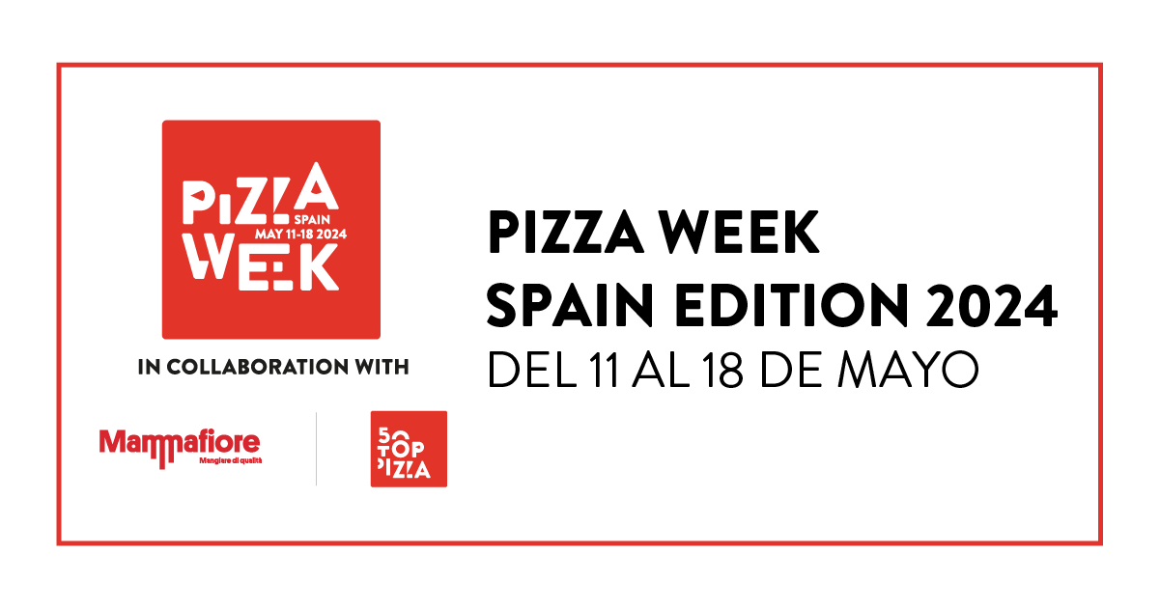

**PIZZA WEEK - SPAIN EDITION 2024, MAY 11 TO MAY 18: A WEEK OF EVENTS IN THE BEST SPANISH PIZZERIAS GUARANTEED BY 50 TOP PIZZA**

**The complete list and program**

From **May 11th** to **May 18th**, the best pizzerias in Spain will be involved in **Pizza Week - Spain Edition 2024**.  
  
**50 Top Pizza**, the first world guide in the sector, announces **the best pizzerias in Spain for the year 2024** and presents the first Spanish edition of Pizza Week, created in collaboration with **Mammafiore**, which will take place in conjunction with the presentation of the **50 Top Pizza Europa 2024** Guide, expected in **Madrid** on **May 13th**.

The selected **independent pizzerias**, together with the **10 artisan chains** located in Spain, will organize a rich series of important events around the country, in which pizza is at the center: **105 addresses** in total, from Madrid to Barcelona, via Valencia and Bilbao, they will be the protagonists of a week full of events, involving master pizza makers, great chefs, sommeliers, products, and producers, in the name of quality and the desire to network. This is an unprecedented event for this wonderful country.

“*A special selection, to celebrate a rapidly growing movement* – underline the curators of 50 Top Pizza, **Barbara Guerra**, **Luciano Pignataro**, and **Albert Sapere** – *which, in recent years, has invested a lot in quality and, year after year, always manages to surprise our inspectors."*

"*We are thrilled to organize Pizza Week - Spain Edition in collaboration with 50 Top Pizza* – says **Irene Carboneras**, **Mammafiore**'s Marketing and Communication Manager – *which aims to give visibility to diversity and support large projects on quality pizza in our Country".*

**You can consult the complete program of Pizza Week - Spain Edition 2024 at the following link:** <https://www.50toppizza.it/pizza-week-spain-edition-2024>

**The Best Independent Pizzerias in Spain 2024**

**7 SENSI, La pizza napoletana** - Las Palmas

**Alimentari** – Seville, 2 locations

**Araldo** - Madrid, 2 locations

**Baldoria** - Madrid

**Cruel Pizza** - Pineda de Mar

**Demaio** – Bilbao, 2 locations

**Frankie Gallo Cha Cha Cha** – Barcelona, 2 locations

**Fratelli Figurato** - Madrid, 2 locations

**Gasparic** - Girona

**Gina Balmesina Pizza Bar** - Barcelona

**Hot Now** - Madrid

**Humo Pizza** - San Sebastián

**Il Figlio di Emiliano** - Barcelona

**Infraganti** – Alicante, 4 locations

**La Balmesina** - Barcelona

**La Pecora Nera** - Rivas-Vaciamadrid

**La Pizzeria** - Madrid

**La Trattoria de Tarifa** - Tarifa

**LACAN** - Las Palmas, 2 locations

**Le Otto** - Castelló de la Plana

**Luna Rossa** - Madrid

**Maximmus Pizza** - Sabadell

**Mecànic Pizza** - Sant Cugat del Vallès

**MO de Movimiento** - Madrid

**Morso Pizza Bar** - Madrid

**Nuova Napoletana** - Paracuellos de Jarama

**Oro di Napoli** - Santa Cruz de Tenerife

**Pizza Radical** - Madrid

**Pizzeria Cosa Nostra** – Almería

**Pizzeria Mamma Mì Pizza & Tradizione Napoletana** - Las Palmas

**Pizzeria Marghe 1889** - Terrassa, 3 locations

**Pizzeria Primavera** - Fuengirola

**Punta** - Barcelona

**Rifugio** - Madrid

**Rustica Napoletana** – Seville, 2 locations

**Santa Chiara** - Palma de Mallorca

**Sartoria Panatieri** – Barcelona, 2 locations

**Trafalgar** **- Cocktail & Pizza Club** - Barcelona

**Vulcanico** - Las Palmas