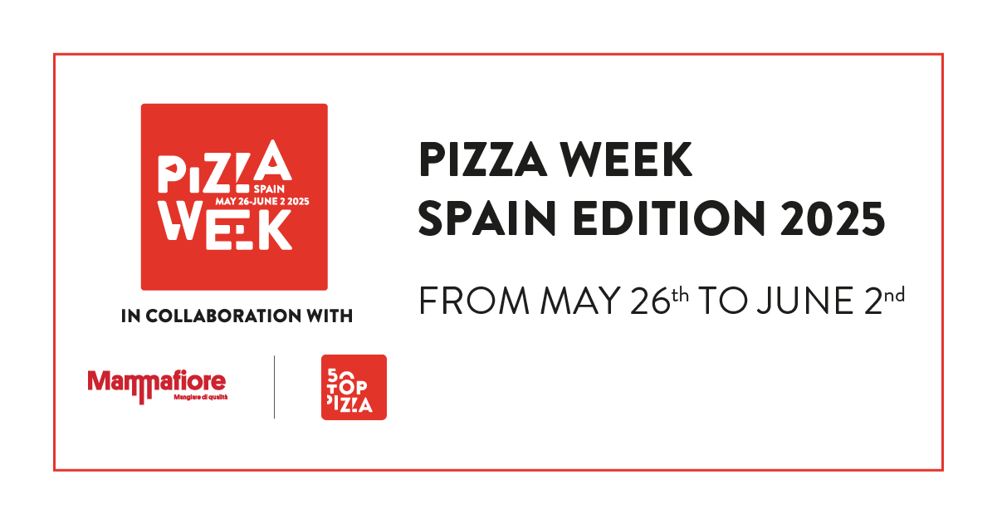

**PIZZA WEEK SPAIN EDITION 2025 FROM MAY 26th TO JUNE 2nd**

**A week of events in the top 45 Spanish pizzerias guaranteed**

**by 50 Top Pizza**

**Complete list and program**

*Madrid, May 14th, 2025* - From **May 26th** to **June 2nd**, the **best pizzerias in Spain for 2025** will be involved in the second edition of **Pizza Week Spain Edition**.

**50 Top Pizza**, the first and most influential global guide in the field, presents the **31 best independent pizzerias in Spain** that will participate in the special Spanish edition of Pizza Week, created in collaboration with **Mammafiore**. On the occasion of the presentation of the **50 Top Pizza Europa 2025** guide, which will be held in **Madrid** on **June 4th**, the ***Road to Madrid*** was launched last May 9th in Lugano, which includes the **Pizza Week Switzerland Edition 2025**, from **May 19th** to **25th**, and the **Pizza Week Spain Edition 2025**, from **May 26th** to **June 2nd**.

The **31 selected independent pizzerias**, together with the **8 artisan pizzeria chains** present in Spain, will organize a rich series of high-profile events throughout the country, which will have pizza at its center: **45 addresses in total**, from Barcelona to Madrid, through Malaga and Seville, they will be the protagonists of a week full of events, and will involve master pizza makers and chefs, products and producers, in the name of quality and the desire to network. It will be an unprecedented event for this wonderful country.

The complete program was presented in Madrid, at the **Circolo Popolare**, by the **Big Mamma** group.

“*A special selection for Spain* – underscore the curators of 50 Top Pizza, **Barbara Guerra**, **Luciano Pignataro** and **Albert Sapere** – *to celebrate a movement that continues to grow, year after year. We thank Mammafiore, partner of the initiative that, like all our partners, allows our inspectors to make their decisions in full autonomy*”.

You can consult the **complete program** of the **Pizza Week Spain Edition 2025** at the following link:

<https://www.50toppizza.it/pizza-week-spain-edition-2025>

**The Best Independent Pizzerias in Spain 2025**

**7 Sensi, La Pizza Napoletana** - Las Palmas

**Alimentari** - Seville

**Araldo** - Madrid

**Baldoria** - Madrid

**Cruel Pizza** - Pineda de Mar

**Demaio** - Bilbao

**Don Vesevius** - Oviedo

**Frankie Gallo Cha Cha Cha** - Barcelona

**Fratelli Figurato** - Madrid

**Gasparic** - Girona

**Gina Balmesina Pizza Bar** - Barcelona

**Infraganti** - Alicante

**La Balmesina** - Barcelona

**La Trattoria by Il Bocconcino** - Adeje

**Le Otto** - Castellón de la Plana

**Marghe 1889** - Lloret de Mar

**Maximmus Pizza** - Sabadell

**Mecànic Pizza** - Sant Cugat del Vallès

**Morso** - Madrid

**Noi Due** - Madrid

**Nuova Napoletana** - Paracuellos de Jarama

**Oro di Napoli** - Santa Cruz de Tenerife

**Pizza Radical** - Madrid

**Pizzeria Primavera** - Fuengirola

**Pizzeria Rifugio** - Madrid

**Punta** - Barcelona

**Reginella** - Madrid

**RústicaNapoletana** - Seville

**Sartoria Panatieri** - Barcelona

**Totò e Peppino** - Madrid

**TRAFALGAR** - Barcelona