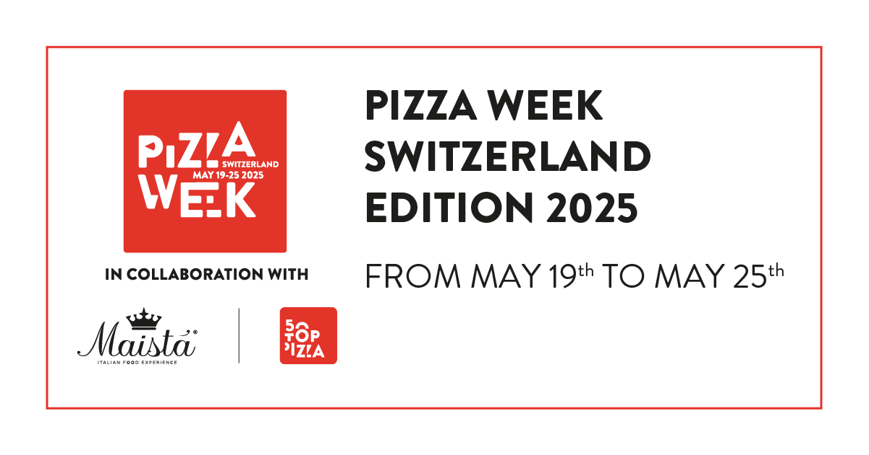PIZZA WEEK SWITZERLAND EDITION 2025, MAY 19th-25th

A week of events at the top 22 swiss pizzerias guaranteed
by 50 Top Pizza

Complete list and program

Lugano, May 9th, 2025 - From May 19th to May 25th, the best pizzerias in Switzerland will be taking part in the first Pizza Week Switzerland Edition 2025.

50 Top Pizza, the first and most influential global guide in the field, presents the 16 best independent pizzerias in Switzerland that will participate in the special Swiss edition of Pizza Week, created in collaboration with Maistà. On the occasion of the presentation of the 50 Top Pizza Europa 2025 guide, scheduled in Madrid on June 4th, the Road to Madrid will begin, which will include both the Pizza Week Switzerland Edition 2025, from May 19th to May 25th, and the Pizza Week Spain Edition 2025, from May 26th to June 2nd.

The 16 selected independent pizzerias, together with the 4 artisan pizzeria chains located in Switzerland, will organize a rich series of high-profile events throughout the country, focused on pizza: 22 addresses in total, from Zurich to Geneva, through Bellinzona and Lugano, they will be the protagonists of a week full of events, and they will involve master pizza makers and chefs, products and producers, in the name of quality and the desire to network. It will be an unprecedented event for this wonderful country.

The full program was presented during an event promoted by the Maistà company at the prestigious Palazzo Mantegazza in Lugano.

“A special selection for Switzerland – underline the curators of 50 Top Pizza, Barbara Guerra, Luciano Pignataro and Albert Sapere – to celebrate a movement that we all hope will continue to grow in the coming years. We thank Maistà, partner of the initiative that, like all our other partners, allows our inspectors to make their decisions in full autonomy”.

At this link you can consult the complete program of the Pizza Week Switzerland Edition 2025: https://www.50toppizza.it/pizza-week-switzerland-edition-2025/

The Best Independent Pizzerias in Switzerland 2025
Acqua e Farina - Lugano
ARCADE - Zurich
ArteChiara - Dietikon
Con Gusto - Zurich
da PONE - Zurich
Elvezia 31 - Lugano
Kytaly - Geneva
Maccarò - Marin-Epagnier
Margherì - Zurich
NA081 - Zurich
Ninni - Aarau
Nocino Pizzeria - Lancy
Più - Zurich
Pizzeria Ciro - Geneva
Pizzeria Verace - Lugano
San Gennaro - Zurich

